Name: ______________________________________ | Date: ___________________

3 momentum cases

The approach you can take to answering a question about momentum changes in a two object collision depends on how you bound the system.

Approach 1 (one-object system): If you define the system as including only one object (object A), then your initial momentum for the system will be only the momentum of that object: (m_{A}* Δv_{A}),  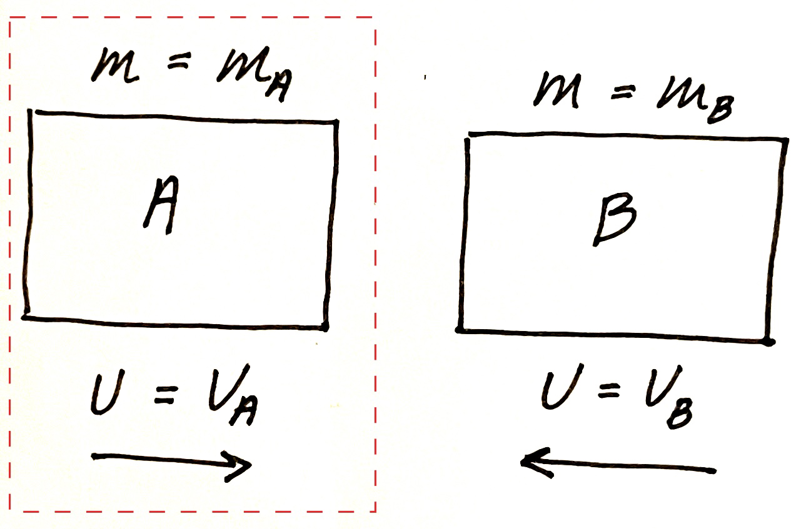  Any change in momentum of the system must come from an object outside of the system exerting a force, which must lose exactly the amount of momentum gained by the system. Thus you will model such a system mathematically by determining the gain (or loss) in momentum of the single-object system (m_{A}* Δv_{A}), and setting that equal to the loss (or gain) in momentum of the object outside of the system -(m_{B} * Δv_{B}).  The second object (object B) has lost momentum in this example, so its momentum term will be negative. Remember that the change in velocity of one of the objects may also be in the negative direction!  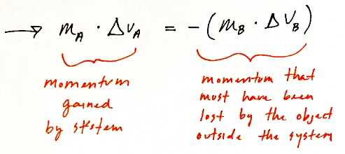 |  | Approach 2 (two-object system): If you define the system as including both objects involved in the collision, then your initial momentum for the system (before the collision) will be the sum of the initial momentums of both objects (m_{A} * v_{A before} + m_{B} * v_{B before}).  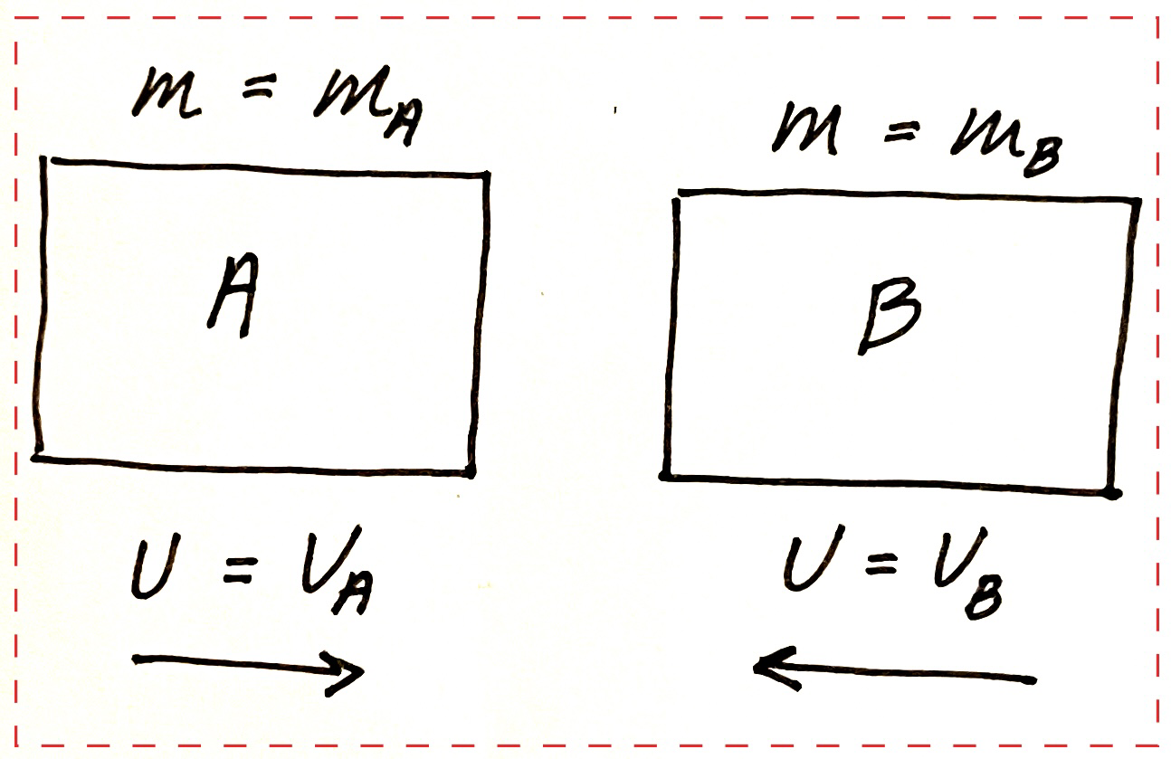  Because there is no external force acting on the system in the system that is bounded this way, the total momentum of the system after the collision should not change, in other words, the change of momentum will be 0.  Thus you will model such a system mathematically by setting the initial momentum (m_{A} *v_{A before} + m_{B} * v_{B before}) equal to the final momentum (M_{A} * V_{A after} + M_{B} * V_{B after})  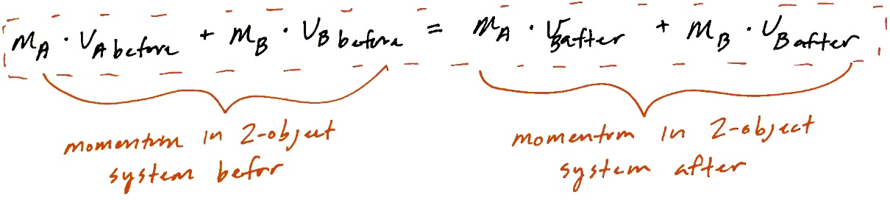

You might notice that these approaches are actually doing the same math, but in a different way.
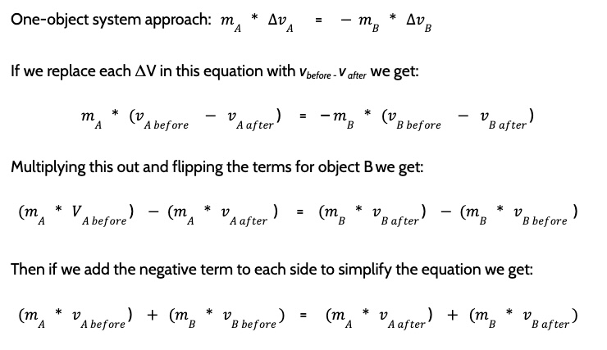
Which is exactly the same model that we use in the two-object system approach!
Question 1: This data describes the outcome of a collision between two grocery carts, one empty (B) and one with groceries in it (A). |  | Grocery cart | Mass | Velocity before  the collision | Velocity after  the collision
 |  | A | 60 kg | 0.50 m/s | 0.25 m/s
 |  | B |  | 0 m/s | 0.75 m/s

1a). Is this collision elastic, or inelastic? How do you know?

1b). What does our mathematical model predict the mass of grocery cart B must be?

1c). How many times larger was the magnitude of the change in velocity for cart B compared to cart A?

Question 2: A head on collision occurs between two vehicles. The smaller vehicle is 1500 kg and is moving at 30 mph before the collision. The larger car is 2250 kg and is moving at 30 mph in the opposite direction before the collision. The larger car comes to a stop as a result of the contact forces in the collision. For each graph, indicate whether it shows the expected velocity change in the smaller vehicle? (write yes or no for each, and explain why)
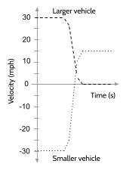 | 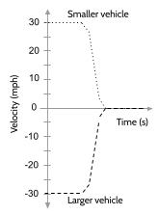 | 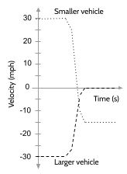 | 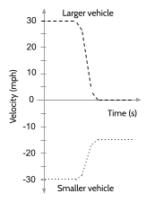
2a). | 2b). | 2c). | 2d).
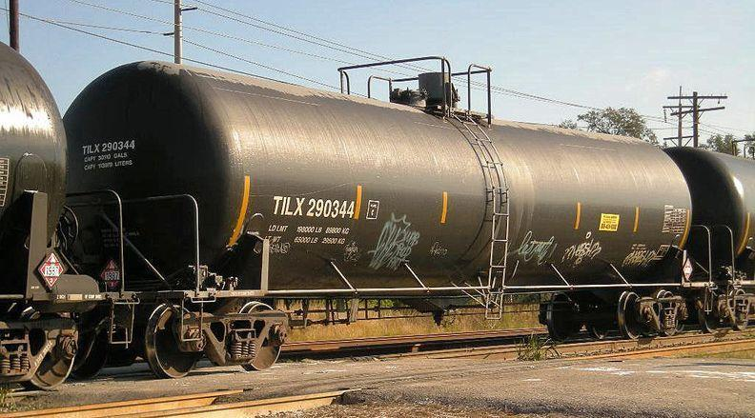
Question 3: Switcher engines help move train cars around on tracks in train yards. To save time and fuel in this process, they sometimes uncouple a car they have been pushing, so it coasts along the track until it collides with a chain of stationary cars it needs to be connected to.
When this happens the couplers on the end of the train cars automatically catch, and a longer chain of cars is formed. The collision sometimes results in the entire longer chain of cars moving forward in the direction of the push.

3a). Is this collision elastic, or inelastic? How do you know?

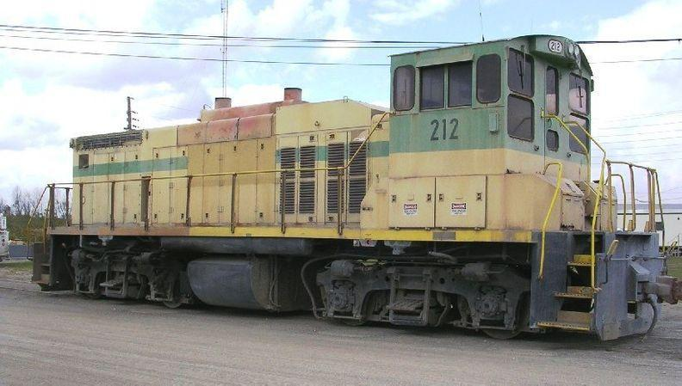
3b). How fast must a tanker car have been moving before such a collision if the following is true?
- The tanker car collides with and couples to 11 other tanker cars. You can assume that all 11 tanker cars together form a single object with mass ( 11 * m_{1 tanker car} ).
- The entire set of 12 cars ends up moving together at 0.2 m/s as a result of this collision.
- Every tanker car has a mass of 119,000 kg.

